Where to Upload Documents in PERIS
- Some departments require that you upload your documents to PERIS yourself. Here are screenshots of where to upload each document.
- Each applicant/application is different, so it’s possible that you might have additional documents.

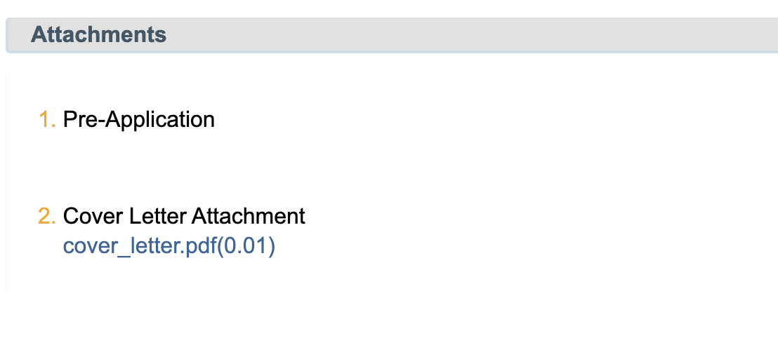
SF424 (R&R) V2.0

Research & Other Related Project Information V1.4
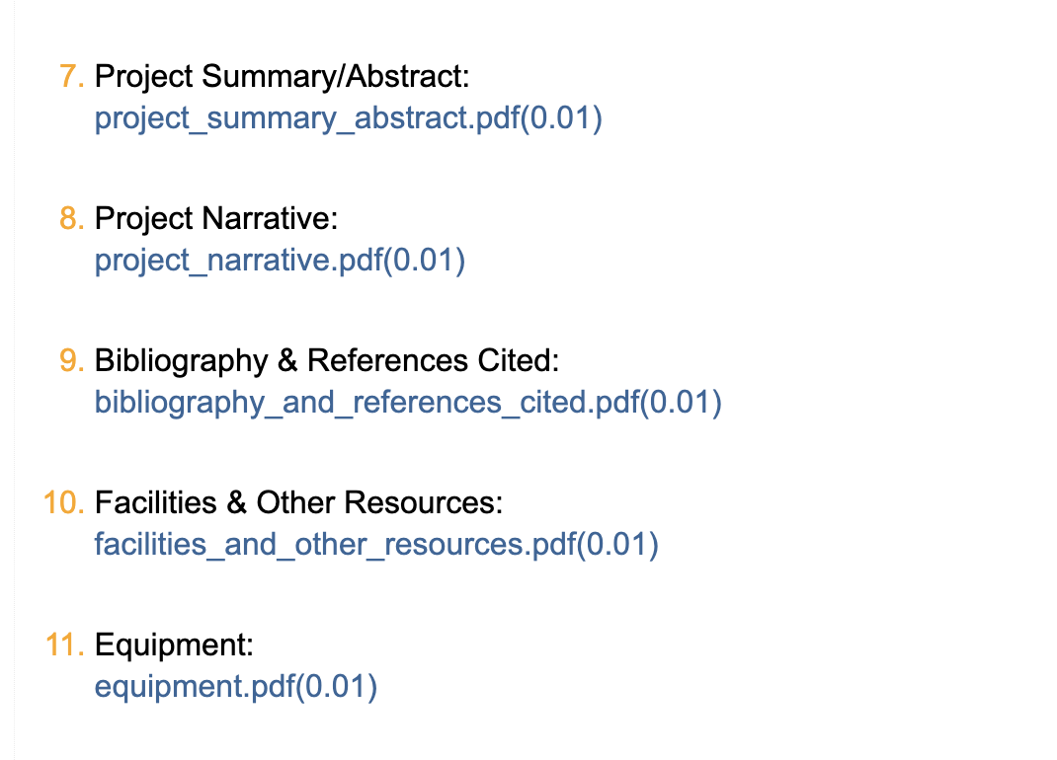
Research and Related Senior/Key Person Profile (Expanded V2.0)
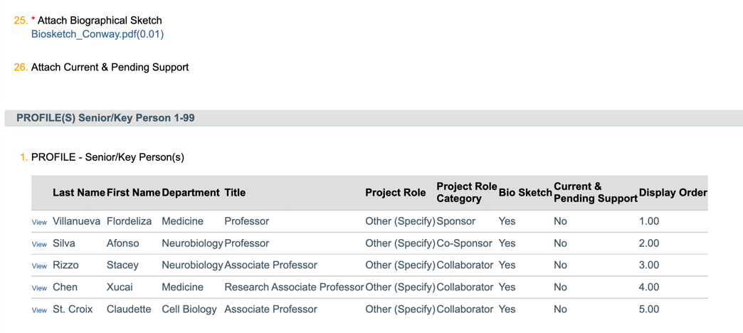

PHS Fellowship Supplemental Form V5.0
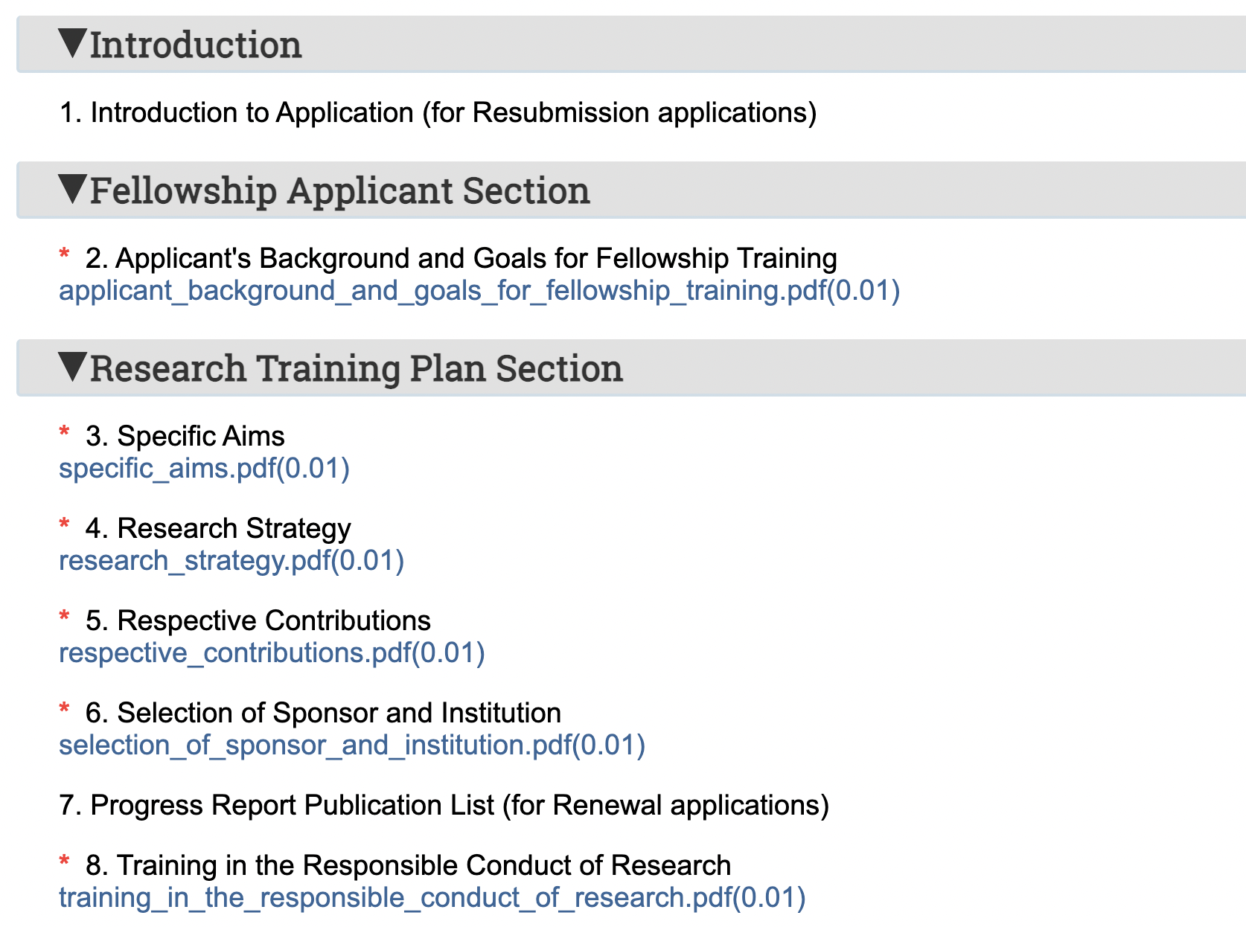
This is where you upload your introduction for a resubmisssion

