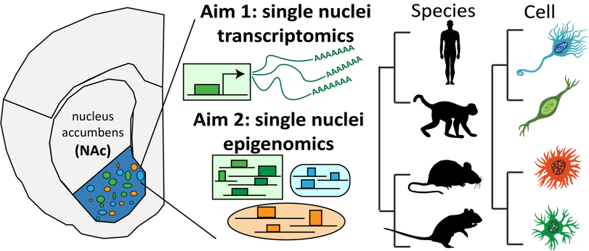
Specific Aims:
Figure 1. Hypothesis: human SUD risk variants enrich in NAc cell type marker genes and CREs conserved in primates and rodents. I propose to define the molecular basis of genetic predisposition to SUD with single-cell genomics and novel computational algorithms.
The prevalence for substance use disorders (SUD) has substantially increased worldwide in the last three decades¹. Human genetic studies have identified genetic factors underlying of SUD, reporting up to 80% heritability^{2–5}. Similarly, rodent studies also found that genetic variation explains a significant portion of addiction behaviors^{6–10}. The molecular basis for these SUD predispositions in humans and model organisms, however, remains unknown. Thus, the overall goal of this proposal is to define the molecular basis of genetic predisposition to SUD.
SUDs hijack many components of the reward neural circuit, especially cells in the nucleus accumbens (NAc)^{11–15}. Genetic risk variants associated with complex neuro-behavioral traits, such as addiction, demonstrably impact gene cis regulatory elements (CREs)^{16–27}. CREs are largely cell type-specific^{28–34} and are conserved across species at varying degrees^{35–40}. Therefore, identifying which cells utilizing genes and CREs affected by SUD risk variants can provide insight into the context-dependent molecular basis of SUD genetic risk (Figure 1). Our lab in collaboration with Dr. William R. Stauffer (Letter of Support) used single nuclei transcriptomics to show that macaques have unique NAc cell types and marker genes that may be relevant to human addiction⁴¹. We further showed that human and orthologous mouse CREs of several NAc cell types enrich for SUD risk variants⁴². Whether orthologs of these genes and CREs detected in model organisms stay cell type-specific or maintain biological relevance to human SUD remains to be delineated.
Through analyzing our inhouse and publicly available single cell datasets, I am poised to test the overarching hypothesis that human SUD risk variants enrich in NAc cell type marker genes and CREs that are conserved in primates and rodents (Figure 1). Understanding which NAc genes and CREs may be affected by human risk variants for SUD, particularly those measurably conserved in primates and rodents, will revolutionize the playbook for translating human polygenic diseases and disorders to model organisms, direct future studies into molecular mechanisms of SUD, and ultimately enable progress to curb the substance addiction epidemic.
Aim 1: Identify conserved, active NAc marker genes and relation to human SUD genetic risk. Due to the evolutionary conservation of mammalian genes, I hypothesize that SUD risk variants enrich near primate-rodent conserved marker genes of NAc cell types. Results of Aim 1 will systematically associate the heterogeneous collections of SUD loci to candidate cell types and marker genes that classify conserved NAc cell type-specificity.
- Evaluate the molecular composition of NAc cell types through identification of marker gene profiles using single nucleus RNA sequencing (snRNA-seq) independently in mice^{43–45}, rats⁴⁶, macaques⁴¹, and humans⁴⁷.
- Develop a graphical model to jointly compare single cell gene expression across the species and cell types employing the principle of maximum parsimony over known evolution and neurodevelopmental hierarchies.
- Determine whether SUD risk variants^{48–54} are enriched in conserved or divergent NAc marker genes.
Aim 2: Identify conserved, active NAc cis-regulatory elements and relation to human SUD genetic risk. Due to the lower evolutionary selection for CREs than genes, I will investigate whether human SUD risk variants enrich in primate-conserved or rodent-primate shared cell type-specific CREs. Aim 2 results will provide an important epigenomic view to complement gene-based findings in Aim 1 and provide genome-wide CRE candidates in other species that can be targeted to model the spectrum of human polygenic risk in vivo.
- Identify the putative CREs with single nucleus assays for transposase accessible chromatin (snATAC-seq) in NAc cell types separately in mice⁵⁵, rats, macaques, and humans.
- Extend the model from Aim 1b to model single cell putative CRE activity applying maximum parsimony to the same hierarchies in species and neural cell types.
- Determine whether SUD risk variants enrich for conserved, active or divergent NAc cell type-specific CREs.
The identification of genetic risk loci for SUD in humans gives us the opportunity to identify molecular mechanisms contributing to addiction behavior. This proposal will use innovative genomic technologies, integrate the molecular evolution of genes and CREs, and illuminate how human SUD risk variants might target gene regulatory mechanisms in cells of the NAc. Completion of this proposal will provide excellent training in developing machine learning algorithms and applying novel approaches to study human disease mechanisms. Importantly, this proposal will lay the foundation of my academic career as an independent physician-scientist.

