MSTP MS3 and MS4 Handbook
Tax Information for T32 and F30 Fellows 2
Predoctoral Fellows & Training Grant Recipients tax information 2
MS3/MS4 NOT on F30/T32 Tax Information 3
MSTP Return to Medical School Rules 3
Guidelines for Transitioning Back to Medical School 4
Suggested return times for different specialities. 5
Clearance Information 6
Six to Eight Weeks in Advance Before returning to Med School: 6
PENNSYLVANIA STATE CHILD ABUSE HISTORY CERTIFICATION/PA ACT 33 ($10.00 fee) 1
PENNSYLVANIA STATE POLICE CRIMINAL RECORD CHECK/PA ACT 34 ($22.00 fee) 2
FBI FINGERPRINTING CLEARANCE/PA ACT 73 (estimated $23.85 fee) 2
Completed Report Samples 3
CME Information 4
Four Weeks in Advance: 4
One Week in Advance: 5
MS3 5
Uworld subscription for 1 year 5
F30 Awards during Medical School 5
MS4 5
MSTP Research Elective (MSTP 5975) 5
MSTP Postdoctoral Fellowship for students who graduate in December. 6
2020 Survey of All Residency Program Directors 6
UPSOM PROGRAM DIRECTORS RECOMMEND THAT MS4 STUDENTS CONSIDER THE FOLLOWING ROTATIONS 7
Applying for residency 12
Diploma Day (specific for 2023, but timelines will be similar for subsequent years) 12
Important information regarding regalia: 12
MS4 Bootcamp (for students who graduate in May) 13

Tax Information for T32 and F30 Fellows
This information may be of help as you figure out what your tax payment will be. Generally, you will be filing quarterly.
As an F30 or T32 fellow, your stipend comes from two different sources:
1) NRSA stipend provided by the grant and
2) any stipend that you receive in excess of that.

The majority of your stipend comes from the T32 or F30 (NRSA stipend is currently $27,144). The University/your mentor provides an internal supplement to that stipend through non-federal sponsored funds that bring your total stipend up to $33,360 (current stipend as of 9/1/2022). Our understanding is that the NRSA stipend is not taxed, but the internal supplement is taxed and generates a W2 form.

Predoctoral Fellows & Training Grant Recipients tax information
Please note that the MSTP and University cannot give any tax advice or guidance. Please reach out to a tax accountant if you have any questions.
Non-resident alien foreign nationals seeking taxation information should refer to the Global Pay section.
The University does not withhold taxes or report your fellowship or training grant on a W-2. If you are a candidate for a degree, then the portion of the fellowship or training grant that is used for qualified educational expenses is not considered federally taxable income to you.
Any amount you receive that is not used for qualified educational expenses is taxable. The IRS defines qualified educational expenses as tuition and fees required to enroll at or attend an eligible educational institution; and course-related expenses, such as books, supplies, and equipment that are required for the courses at the eligible educational institution.
Amounts used to pay for non-qualified expenses such as room and board, travel, research, clerical help, or equipment and other expenses that aren’t required for enrollment in or attendance at an eligible educational institution are considered taxable.
IRS publication 970 provides details and a worksheet for determining the taxable portion of your fellowship or training grant.
Predoctoral Fellows and Trainees may be required to pay estimated taxes on a quarterly basis to avoid any underpayment penalties. Refer to IRS Publication 505, Tax Withholding and Estimated Tax, Ch. 2, for additional information.
These fellowships and training grants are not taxable in Pennsylvania, because the primary purpose is to further the recipient’s education or training, and either they are not payments for services rendered or the benefits from any services performed are very minimal. Pennsylvania provides guidance on the taxability of fellowships and grants under section b of Title 61 Pa. Code §101.6.

MS3/MS4 NOT on F30/T32 Tax Information
If you are not supported by an F30/T32, then you are supported internally. It is our understanding that internal funding is taxed and generates a W2 form.

MSTP Return to Medical School Rules

- The October the year before a student return to medical school, the student must inform the MSTP Director and the Executive Director that you plan to return to medical school the following year.
- In December you will have a group meeting to discuss the return with the MSTP advisory dean (Dr. Bonifacino). Please become familiar with Dr. B as she can advocate for you if the lottery does not work out the way you hoped it would.
- Schedule an individual meeting with the MSTP advisory dean (Dr. Bonifacino) to plan your schedule preferences. Please make sure that the clinical clerkship template has been completed and bring this with you to this meeting to discuss. More information in number 4 below.
  - Bonifacino: https://outlook.office365.com/owa/calendar/HouseBonifacino@upmchs.onmicrosoft.com/bookings/
- The clerkship lottery opens in mid-January for returns dates for the full year.
  - The clerkship template is new every year. Kathy will obtain this document and make sure you receive the correct version.
- Students must defend their PhD thesis and submit 3 documents listed in #7 at least one month before returning to medical school.
  - Here are guidelines from Pitt SOM, CMU BME, This website provides lots of information for the SOM PhD students. https://somgrad.pitt.edu/graduation
  - CMU Graduation Policies: https://cit.cmu.edu/education/academic-policies/graduate-policies/thesis-dissertation.html
- Your thesis document must contain a section relating your research to health or disease. This may be brief (1-3 pages) and is an opportunity to consider translational paths that might arise from your work.
  - You must also have presented on the responsible conduct of research to your lab. Please inform Kathy of the date of the presentation.
- Students must complete 2 Longitudinal Clinical Course clerkships (two 20-week sessions) before returning to medical school and a 2-week (or 7 days) Junior Hospitalist Service (LCC 3).
- After your defense, provide copies of the following pages from your official and final PhD thesis to the MSTP office and meet with Kathleen Hansell-Prigg regarding your tuition, stipend, health insurance and transfer of F30 grant (if applicable).
- For your defense, Kathy will need:
  - Title page
  - Abstract page
  - Committee signature page
  - Electronic Thesis Defense
  - The MSTP office will verify with your Graduate Program Director that you have fulfilled all requirements for your PhD degree and will graduate at the end of the academic term of your defense.
  - The student’s stipend will not be paid until this information is received. A student may not return to medical school if they are still working on their ETD.
- The MSTP office will assume responsibility for the medical school tuition and stipend after the documents listed under #7 are submitted to the office and upon verification from your Graduate Program Director.

Guidelines for Transitioning Back to Medical School
- Comply with Return to Medical School rules.
- Complete the MS3/4 clinical training plan with justification for electives over and above the required rotations. You only need 17 months of rotations to graduate.
- To complete your clinical training, you may elect the July, September or May return track.
- Returning at the start of September allows 4 terms for completion (up to May graduation the following year, 24 months total clinical work).
- Returning in May requires graduation the following December (23 months clinical work).
- A compressed option (returning in January and graduating the following May, 19 months clinical work) is challenging, particularly because there is less time back in medical school before applying to residency and taking the Step 2 Boards. This return date is impractical for those entering fields that require away rotations. To ensure that this these challenges can reasonably be addressed, a January return is only allowed with approval from Dr. Steinman.
- Keep in mind that the MSTP office will pay no more than 4 terms (long track) and 3 terms (short track) of medical school tuition and 21 months of stipend We go up to at most 21 months of MSTP stipend after graduate school (51 months of total MSTP stipend support):
- PRE-MS1—3 months MS1—12 months + MS2 -12 months + summer after MS2—3 months + (long track) MS3—9 months + MS4 12 months = 51 months total stipend support.
  - Up to 21 months maximum after graduate school
    - long track (MSTP A) 21 months,
    - January return (MSTP B) 17 months – with approval form Dr. Steinman,
    - May return, Dec Grad (MSTP C) 16 months,
    - Sept return, Dec Grad (MSTP D) 16 months.
Please see above training tracks that are available to the MSTP students.

Suggested return times for different specialities.
Strongly suggested September return –
- dermatology,
- emergency medicine,
- neurosurgery,
- orthopedic surgery,
- ENT,
- plastic surgery,
- radiation oncology,
- urology and
- vascular surgery,
- CT surgery
- OBY-GN (two OBY-GN rotations are required before students apply for match)

These specialties require away rotations; we are working on gathering this information to distribute to students. May return is also fine for the above specialties.

Required Clerkships | Months | Weeks
Adult Inpatient Medicine | 2 | 8
Adult Outpatient Medicine | 1 | 4
Neurology | 1 | 4
Psychiatry | 1 | 4
Pediatrics | 2 | 8
Family Medicine | 1 | 4
Obstetrics & Gynecology | 1 | 4
Specialty Care Clerkship | 1 | 4
Surgery & Perioperative Care | 2 | 8
Total Core Clerkships | 12 | 48
Acting Internship | 1 | 4
LCC Credit | 1 | 4
Remaining Clinical rotations | 3 | 12
Total Required for graduation | 17 | 68
Interview/Vacation - Optional | 2 | 8

Clearance Information
Since you have been out of medical school for 3+ years, your clearances have expired.

Six to Eight Weeks in Advance Before returning to Med School:

IMMUNIZATIONS/CERTIFICATIONS/CLEARANCES
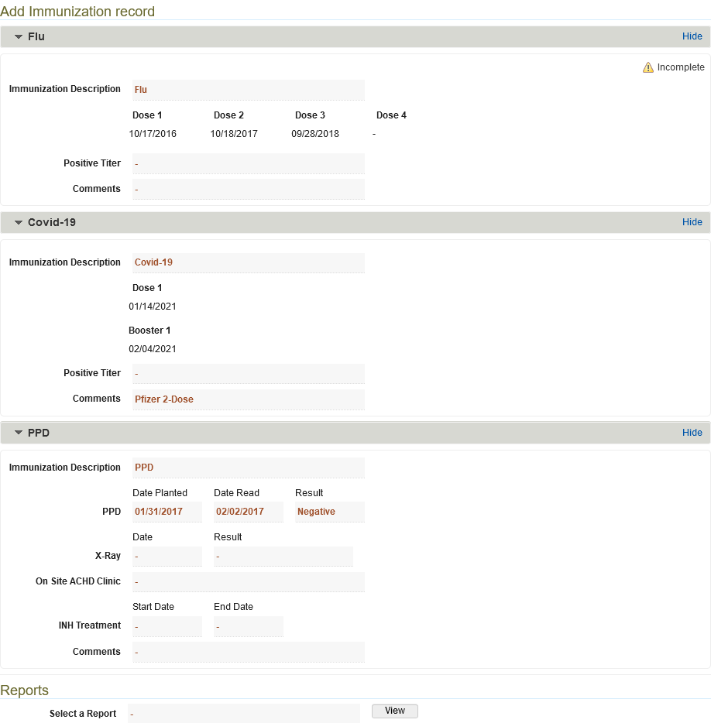
For Immunizations, Certifications, or Clearances questions, contact the Student Affairs Records Officer, Heath Lettich, hnl20@pitt.edu 412-648-8987 or stop by in person to chat - S594 Scaife Hall.

Log onto ‘Navigator’, then go to Amp-Up to view your immunization/certifications. You will need this to determine what is current and what needs updating. It may look like this.

IMMUNIZATIONS
Most of your immunizations will not need up dating but there are 2 that may need to be considered.
1) PPD, this is required once you enter Medical Student and you only need to retest if you are symptomatic.
2) Tdap Your Tdap immunization is good for 10 years. The date that appears in the field above
needs to be within 10 years of your expected graduation. An example would be if you are expected to graduate June 2018, your Tetanus shot cannot be dated later than June 2008. If it is, you will need to get a Tdap shot and provide Student Affairs with documentation before reentering Med School.
3) Flu Shot UPMC policy dictates that annual flu shots are now mandatory for anyone who will be
in patient care areas during flu season. If you are returning to UPMC’s defined flu months (usually November through April), you must get a flu shot and provide documentation of it to Student Affairs before reentering Med School. If you cannot get the flu shot for medical reasons, please contact the Student Affairs Records Officer for instructions on how to document a medical exemption.

For more information on Immunization Requirements, see “What is Required” in Navigator>Student.
Forms

CLEARANCES
Clearances – Your leave of absence did include time away from Pitt. If you have been away from medical school for more than 5 years you will need to get new clearances. Instructions for obtaining clearances is found in Navigator: Home>Student Forms>MS1>Clearance Instructions.
Clearances can take up to 8 weeks to complete, so be sure to start early if you need to reapply.

MANDATORY CRIMINAL BACKGROUND CHECKS
The total cost for the three clearances is $55.85 at your expense, but the MSTP will reimburse. Please submit your receipts the MSTP Office.

Be sure to allow time to receive your results as this process can take 4-6 weeks.
Clearance applications, unofficial results, or third party background checks do not satisfy the requirement. Additional information about clearance requirements in Pennsylvania is available at: https://www.dhs.pa.gov/providers/Clearances-and-Licensing/Pages/Clearances-and-Licensing.aspx#

PENNSYLVANIA STATE CHILD ABUSE HISTORY CERTIFICATION/PA ACT 33 ($10.00 fee)
  - https://www.compass.state.pa.us/CWIS
  - Select “CREATE INDIVIDUAL ACCOUNT”
  - Navigate through the Keystone ID account creation and check your email for the temporary password
  - Return to https://www.compass.state.pa.us/CWIS
  - Select “INDIVIDUAL LOGIN” and follow instructions to change password and log back in
  - Select “Access Clearances” Students should check the CHILD CARE EMPLOYMENT option for the Purpose of Clearance.
  - Form may be mailed in or submitted online. We will accept a print-out of online certificate, certificate received by mail or an emailed PDF.

PENNSYLVANIA STATE POLICE CRIMINAL RECORD CHECK/PA ACT 34 ($22.00 fee)
  - https://epatch.state.pa.us/Home.jsp
  - Select “Submit a New record Check (requires a credit card)”
  - Read the terms and click “Accept”
  - Enter an “Individual Request”, not a Company Request
  - Reason for Request: Employment, or Child Care Employment
  - Proceed through the remaining screens.
  - Print-out of certificate or emailed PDF is acceptable. Be sure you click the link to see an actual certificate, not just the confirmation of whether there was a record found or not.

FBI FINGERPRINTING CLEARANCE/PA ACT 73 (estimated $23.85 fee)
  - https://uenroll.identogo.com
  - Students should use service code: 1KG756
  - Select “Schedule or Manage Appointment” or “Submit Fingerprint Card by Mail” if you reside outside of PA.
  - Be sure to read all instructions carefully as you proceed.
  - Employer Information: University of Pittsburgh, 3550 Terrace St., S594 Scaife Hall, Pittsburgh, PA 15261
  - An Act 73 original certificate will be mailed to you 4-6 weeks after mailing in your fingerprint cards or after being fingerprinted at a Pennsylvania IdentoGO site. Be sure to provide an address where you can easily access mail.

US students who are unable to be printed electronically at an IdentoGo site within Pennsylvania should register with IdentoGo online at the above link and then mail their fingerprint cards to IdentoGo as instructed on IdentoGo’s website. Please enter the service code and then choose “Submit a Fingerprint Card by Mail for instructions”. If you encounter any problems completing this process, contact IdentoGo at 1-844-321-2124.

Please see next page for examples of how the completed reports should look.

Still have questions? Need help?
Contact te Office of Student Affairs Records Officer at somregistrar@pitt.edu
Steven Winsor
Registrar
412-648-8935 | drstevewinsor@pitt.edu
Heath Lettich
Records Officer
412-383-0370 | hnl20@pitt.edu

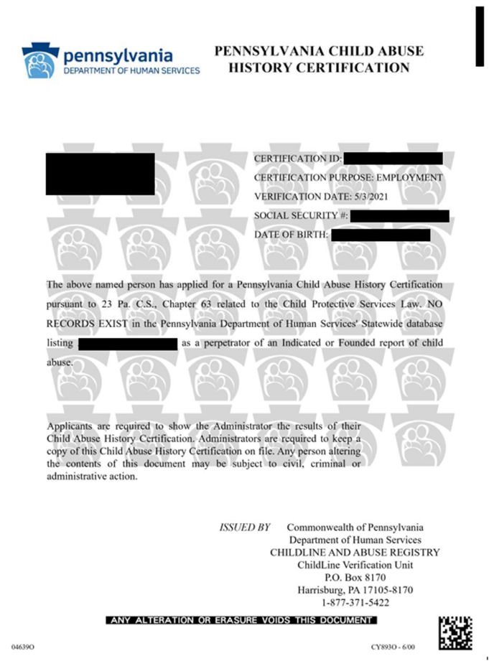
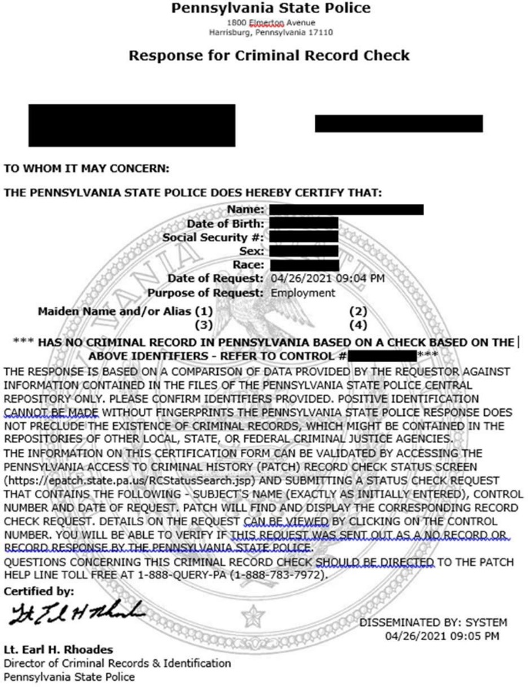
Completed Report Samples
PA Act 33
PA Act 34

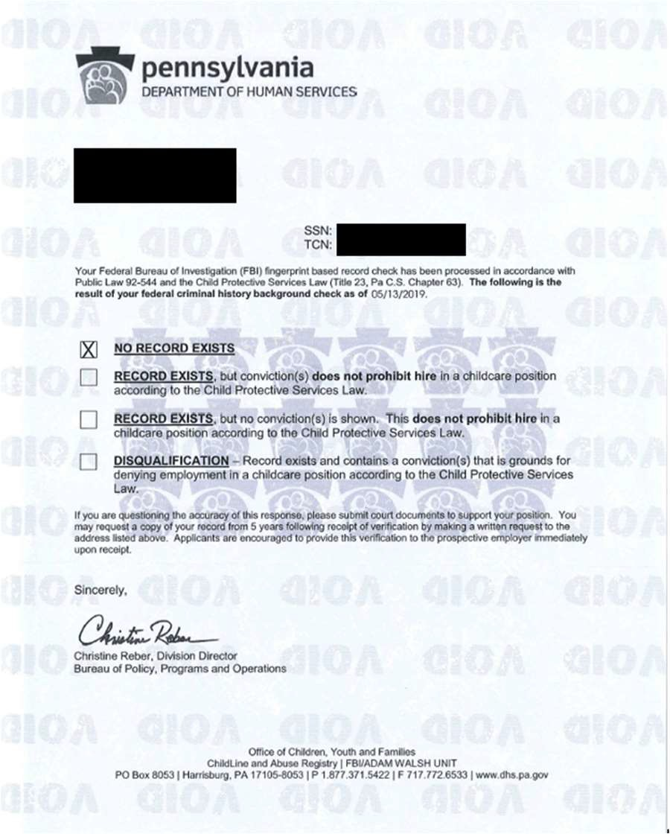
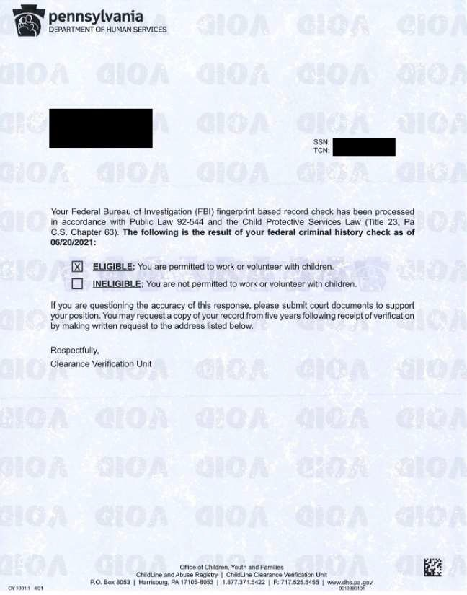

PA Act 73
Before 04/2021

PA Act 73
After 04/2021

CERTIFICATIONS
1) CPR – This box indicates the date your certification expires; it is only good for 2 years.
Please contact the Center for Emergency Medicine at 412-647-4242, or check their website www.centerem.org/ to schedule a CPR for Healthcare Providers class to update this certification. Classes are held monthly.

Returning MSTP students going into the 3rd year are permitted to register for the BLS/CPR at no cost to them. MSTP can schedule a time to come in on Thursday, May 4 for BLS/CPR.

Center for Emergency Medicine of Western PA
CPR Training – Office of Education (centerem.org)
American Red Cross
CPR Training with Red Cross | Red Cross
American Heart Association
American Heart Association CPR & First Aid
After you have gotten re-certified, please send us a copy of your certificate/card.
CEM has switched to eCards. Paper BLS certification cards have been phased out. Upon completing the training, you must activate your new eCard using the activation code you will receive in an email from the American Heart Association (AHA). If you complete the training outside of MS-1 Orientation or Pre-Clerkship Week, please download the card and send it in PDF to somregistrar@pitt.edu prior to your return.
2) Mask Fit – You need to be mask-fitted every two years. You can contact the University of Pittsburgh Environmental Health and Safety Department at 412-624-8642 to schedule an appointment. You will want to be fitted for the 3M N95 mask and the Kimberly Clark Tecnol PFR95 mask. Please provide documentation of completion in PDF to somregistrar@pitt.edu prior to your return.
3) Standard Precautions and Bloodborne Pathogens Training - This is the date that you last completed this module. The Hand Hygiene and Standard Precautions modules were combined as of spring of 2012, and this module is completed annually via your Navigator account. Please provide documentation of completion in PDF to somregistrar@pitt.edu prior to your return.
4) HIPAA – Access the UPMC Information Privacy and Security Awareness Training for Students, Trainees, Health Professionals and Other Individuals Who Are NOT UPMC Employees

CME Information
Even if you are not required to re-certify, it is recommended that you review this material on your own before returning to clinical training.

https://cme.hs.pitt.edu/servlet/IteachControllerServlet?actiontotake=loadmodule&moduleid=6381
a. Log in to your cme.hs.pitt.edu account using your medical student email address and the password you created for that account. There is a link on that site to assist you if you do not recall your password.
b. The website will create a record of your training using your login to identify you. You do not need to submit a paper certificate, even though the site offers you a certificate.
c. Please let someone in OMED and the Student Affairs Office know when this is finished so your completion date can be updated.

Four Weeks in Advance:

UPMC-IMS Computer Account
Contact Steven Winsor, Registrar UPSOM Office of Student Affairs, as early as possible and no later than 4 weeks before your return date to update your IMS account and ensure uninterrupted access. Failure to make these arrangements in advance could cause you to abruptly lose access to patient information while you are in clinical rotations and can take up to 2 weeks to restore once terminated. DrSteveWinsor@pitt.edu, or stop by Student Affairs Office.

One Week in Advance:

Security Card (Student Lounge Access)
You may need your security card access updated. If it is not permitting, you into the Student
Lounge you will need to see the Heath Lettich, hnl20@pitt.eduto reactivate or replace your card.

Health Insurance
If your health insurance will be impacted by your change in status and need assistance, contact Kathy at kjh2@pitt.edu. If you are returning any other time than August, you will need to submit a late enrollment form with your health insurance. This form can be found on the student health insurance portal.

MS3

Uworld subscription for 1 year
MSTP pays for one year of Step 2 Uworld subscription. Each student will be emailed a promotion code that is good for 1 year of Uworld. If you would like to purchase an additional year, you can pay the difference in the UWorld system when using the promotion code. Please do not purchase Uworld on your own, as you will be charged taxes and must pay upfront and be reimbursed.

F30 Awards during Medical School
Students that return with a F30 receive stipend bonus of $250 per month up to $3,000 per year during medical school enrollment. We calculate how many months remain on your F30 and once your employee record has been transferred back to the MSTP we initiate a onetime direct deposit. If you have more than 1 year remaining on your F30, then September of your MS4 year we would do another direct deposit ($250 x months remain).
Your F30 must be transferred to the MSTP office to be eligible for the bonus, please send Kathy your PhD Grant Administrator name and email.
Please note that F31 awards DO NOT receive a bonus of $250/month up to $3,000 per year.

MS4

MSTP Research Elective (MSTP 5975)
This course has been designed for MSTP students to enroll for research electives during the 4th year of medical school. To receive credit and stipend while performing a research elective, here are the steps to be followed:

(1) Four weeks prior to the rotation, a research proposal signed by the research mentor must be submitted to Dr. Steinman and to Kathy Hansell Prigg for approval.

(2) At the end of each 4-week rotation, a lab rotation report must be submitted to the lab mentor and the MSTP office. Research Rotation Evaluation

(3) The research mentor submits a research rotation evaluation to the MSTP office within 1 week of the end date. Research Rotation Evaluation

(4) MSTP Director assigns a grade that is submitted to the Student Affairs office along with the evaluation report within 2 weeks of the end date.

MSTP Postdoctoral Fellowship for students who graduate in December.
Application Deadline: June 1 Decision Date: June 15

Six months before graduating, the MSTP student and proposed University of Pittsburgh mentor together to create a one‐page postdoctoral training plan. This plan, including deliverables, is submitted to the MSTP office for approval. Students with approved training plans are eligible for a 50% stipend subsidy from the Dean and the other 50% covered by the mentor for 5 months. The mentor and Dean Stipend financial commitment is at the appropriate level for the departmental Postdoctoral Associate.

The content of the training plan:
Name of Trainee:
Name of Mentor:
Dates of training:
How will time be spent and what will be learned during the proposed fellowship?
What are the deliverables (i.e., what will you accomplish and how will it be assessed)?
How does training contribute to future career goals?

Attach trainee and mentor NIH biosketch.

Please note that you must complete all MD requirements and pass both your Step 2 CK of your last year before starting your postdoc position. CK must be taken an appropriate number of months in advance for results to be communicated in December. If you do not graduate in December (which requires passage of Boards, you are not eligible for appointment as a MSTP postdoc).

2020 Survey of All Residency Program Directors
Guidance for MS4 students’ Senior Year
All Program Directors at the University of Pittsburgh wrote their recommendations on how medical students should structure their MS4 years so that they are prepared and competitive for their chosen residencies. These recommendations were updated in 2019 and again this year and are provided below. We intend these to be guidelines, not requirements. Students should always be in contact with their departmental advisors and their Advisory Deans for optimal individualized scheduling.
SUMMARY
- If contemplating a specific specialty, a student should try to take an elective early in the fourth year to assure it is the right fit and to potentially get a letter of recommendation.
- Students should not overload MS4 year with electives in chosen specialty. Keep the fourth year broad.
- The MS4 year should include clinical experiences in which direct patient care, true patient responsibility, independence, and autonomy are stressed.
- Case presentation and critical thinking skills are areas for continued emphasis in MSIV year.
- Board scores are important in the initial screen of residency applicants, though many Program Directors recognize the limitation of scores as predictors of residency performance.
- Away rotations are specialty dependent and warrant individual advice regarding if they are desirable and if so, location and timing.
- For those planning surgical fields, the student should continue to develop and refine the basic surgical skills during appropriate electives.
- For all fields, a student should make sure there is at least one direct patient care elective within 6 months of beginning internship.

UPSOM PROGRAM DIRECTORS RECOMMEND THAT MS4 STUDENTS CONSIDER THE FOLLOWING ROTATIONS
*Highly Recommended
**past years’ updates
ANESTHESIOLOGY**
- Anesthesiology 4th year Elective (Pitt)*
- Away Rotations: No more than one away anesthesia rotation
  - Good idea if you really want to go somewhere and will do a good job on the elective.
- Critical Care Medicine
- Pain Medicine
- Pulmonary
- Cardiology
- Medicine or Surgery AI

CARDIOTHORACIC SURGERY**
- CT Critical Care
- Adult Cardiac
- General Thoracic
- Congenital Cardiac

CHILD NEUROLOGY
- Child Neurology elective*
- Pediatrics AI
- Away Rotations: not required.

DERMATOLOGY
- Dermatology*
- Away Rotations: 1-2
- Dermatology Elective*
- Dermatopathology
- Rheumatology
- ID
- Emergency Medicine
- Allergy-Immunology
- Plastic surgery
- Pharmacology ILS

EMERGENCY MEDICINE
- Emergency Medicine (Pitt)*
- Away Rotations: 1 (must)*, 2nd is optional.
- CCM
- Advanced Radiology
- Dermatology
- Toxicology
- Pediatric Emergency Medicine
- Ultrasound Elective

FAMILY MEDICINE
- AI in Family Medicine
- Away Rotations: not required.

GENERAL SURGERY
- Acting Internship in Surgery
  - Before August at a location other than that of MS3 clerkship
- Away Rotations: not required.
- Radiology
- CCM
- Surgery Boot Camp
- 2nd surgery rotation (as an elective) after January
  - General Surgery, GI, Trauma, Surgical Oncology

INTERNAL MEDICINE
- Medicine AI
- Away Rotations: not required.
- PUH MICU
- Radiology
- Consider medicine subspecialty electives of interest.
- Consider Teaching to Teach elective

MEDICINE-PEDIATRICS
- Pediatrics or Medicine AI
- Away Rotations: none required.
- CCM
- Radiology
- Dermatology
- Sports Medicine
- Peds Elective (ID, Pulmonology, NICU)
- IM Elective (Cardiology, Pulmonology, Renal)
- Advanced Radiology
- Dermatology
- Behavioral Health Elective
- Women’s Health

NEURODEVELOPMENTAL DISABILITIES (NDD)
- Pediatrics AI
- 4th year elective in Child Neurology*
- Away Rotations: in Child Neurology or NDD

NEUROLOGICAL SURGERY**
- Neurosurgery Sub-I here as soon as feasible
- Away Rotations: 2-3
- Emergency Medicine
- Neuro ICU/CCM
- Medical ICU/CCM
- Cardiology
- Neuropathology
- Neurology

NEUROLOGY
- Neurology Sub-I
- Away Rotations: not required.
- Neuro ICU
- Outpatient Neurology Elective
- Stroke

OBSTETRICS AND GYNECOLOGY
- OB-GYN Sub I (1-2 for experience and letters)
- Away rotations: not required but recommended for specific target region/program.
- Medicine or Surgery AI
- Light rotation (for Step 2 and do well) before end of July
- Elective where you practice surgical skills (suturing, knot tying)
- Radiology
- Anesthesia
- Emergency Medicine

OPHTHALMOLOGY
- Ophthalmology elective*
- Away rotations: not required.
- Rheumatology
- Neurology
- Neuroradiology
- Dermatology
- Otolaryngology
- OMFS

ORTHOPAEDIC SURGERY
- Orthopedics Sub-I
- Away Rotations: 2-3
- General Medicine
- General Surgery
- Med or Surg ICU
- Radiology
- Emergency Medicine

OTOLARYNGOLOGY
- Otolaryngology elective
- Away Rotations: not required.
- Surgery AI
- Infectious disease
- Endocrinology
- Pulmonary
- Allergy and Immunology
- Rheumatology

PATHOLOGY
- Anatomical Pathology Survey Elective*
- Clinical Pathology Survey Elective*
  - Away Rotations: not required.

PEDIATRICS
- Pediatrics AI*
- Away Rotations: not required but useful to look at specific programs.
- Pediatrics Emergency Medicine*
- Radiology
- Peds subspecialties (ID, Renal, Pulm)
- CCM (adult, PICU, NICU)
- Consider the Teaching to Teach elective

PHYSICAL MEDICINE AND REHABILITATION
  - PM&R elective*
  - PM&R Sub-I*
  - Away rotations: at site of first choice
  - Rheumatology
  - Medicine AI
  - Musculoskeletal or neuro – radiology
  - Neurology

PLASTIC SURGERY
- Plastic Surgery Sub-I, prior to October*
- Away Rotations: 1-2 (prior to October) *
- General Surgery AI
- Neurosurgery
- Orthopedic surgery
- ENT
- Surgical oncology
- Vascular surgery
- Emergency Medicine
- CCM
- Urology

PSYCHIATRY
- Psychiatry Sub-I*
- Away Rotations: not required.
- Internal Medicine or Family Medicine AI
    - (Or Pediatrics AI if you’re thinking child psych or triple board)
- Neurology or neurosurgery
- Infectious Disease
- Cardiology
- Emergency Medicine
- CCM
- Oncology
- Palliative Care
- Pain Medicine
- PM&R

RADIATION ONCOLOGY
- Radiation oncology *
- Away Rotations: 1-2
- Gynecological Oncology
- Medical Oncology
- ENT
- Radiology

RADIOLOGY, DIAGNOSTIC**
- 1 or 2 radiology electives (no more)
- Away Rotations: not required.
- Emergency Medicine
- Pathology
- Pulmonary
- Trauma Surgery
- Vascular Surgery
- CCM

RADIOLOGY, INTERVENTIONAL
- No more than 2 radiology electives
- 1 in diagnostic radiology and 1 in interventional radiology
- Away Rotations: not required.
- Medicine AI
- Emergency Medicine
- Trauma Surgery
- CCM

TRANSITIONAL YEAR
N/A
UROLOGY
- Urology Sub-I*
- Away Rotations: 1
- Urology research*
- General Surgery AI
- CCM
- Nephrology
- Internal Medicine
- Pediatric Surgery
- Vascular Surgery

VASCULAR SURGERY
- Vascular Surgery AI*
- Away rotations: 1

Applying for residency
The 2021 MS4 class has put together a guide, https://docs.google.com/document/d/1X0a-BHZqb3qYJB0gL-jr2El4-_PnvTjA/edit

Diploma Day (specific for 2023, but timelines will be similar for subsequent years)

Important information regarding regalia:
Regalia is required to participate in the ceremony. You can no longer purchase from the website, so you will have to purchase regalia from the University Book Store (University Store: 412-648-1455 or email at specialorders@bc.pitt.edu). When you contact the Book Store, please tell them which degree (PhD) you are receiving from the School of Medicine or other School. You will also wear the regalia that the School of Medicine has ordered for you, however you will need to order the hood for your PhD as well.
Important information regarding the ceremony:
- Date: Sunday, May 21, 2023
- Ceremony Time: 11 am (2 hour event)
- Graduates must arrive at 8:00am – enter through the main entrance of Soldiers and Sailors (EAT BREAKFAST BEFORE)
- Parking for graduates will be in the Soldiers and Sailors lot.
- Report to the Grand Ballroom (3rd Floor) at 8am

Attire: Business
- Suit Jacket: (may be hot)
- Be mindful of your shoes especially heels so you don’t trip
Regalia Rental:
  - The University of Pittsburgh Bookstore MANAGES Graduation Regalia
  - Estimated Cost: $174 / Late fee for late submissions
  - OSA will forward an email from the bookstore (with a link) to submit all information for
- ordering regalia. KEEP AND EYE OUT FOR THIS EMAIL in APRIL
  - The bookstore will provide dates/times to pick up regalia
  - You are responsible for bringing the FULL REGALIA SET to graduation. WE DO NOT HAVE
EXTRA ITEMS
Regalia Return:
  - The University of Pittsburgh Bookstore will be on site the day of graduation to collect all
- regalia items
MD/PhD and Special Studies:
- You will receive additional information from the Graduate Office
- You will need 2 hoods for Diploma day, one for the MD degree, one for the PhD degree

MS4 Bootcamp (for students who graduate in May)
Highly suggested but not required for the MSTP class.
- To integrate clinical skills and knowledge in preparation for internship.
- To integrate knowledge obtained throughout the four years of medical school and translate it into treatment of complex patients with multi-system issues.
- To interpret disease processes on chest x-rays, abdominal films, and CT scans.
- To learn the proper way to communicate with patients, parents of patients, and other health care providers.
- To manage (through simulation) a variety of urgent patient situations the student may encounter while on call in the hospital.
- To help students develop essential and durable approaches to personal and financial wellness.
- To become familiar with engaging consultants in patient care.
- To become familiar with responding to on-call phone calls from nurses and other health professionals.

